**Introduction:**

The most common cause of blindness due to diabetes is “Diabetic Retinopathy”. Diabetes affects the nerve layer (retina or net layer) of the eye and the capillaries in this layer, disrupting its work and causing vision loss. Retinal disorders due to diabetes are called diabetic retinopathy.

Elbow Method:

K-Means clustering is the most popular unsupervised machine learning algorithm. K-Means clustering is used to find intrinsic groups within the unlabelled dataset and draw inferences from them.

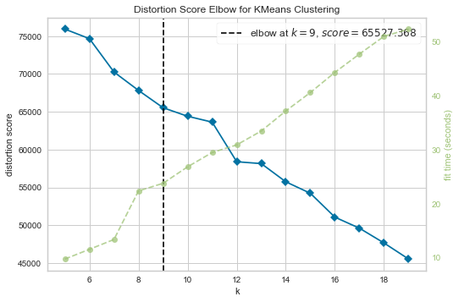

We can see that if K increases, average distortion will decrease. Then each cluster will have fewer constituent instances, and the instances will be closer to their respective centroids. However, the improvements in average distortion will decline as K increases.

at which we should stop dividing the data into further clusters.

So, I have changed the value of k and find relatively higher classification accuracy of 62% with k=9.

**Visualizing resized train cropped images:**

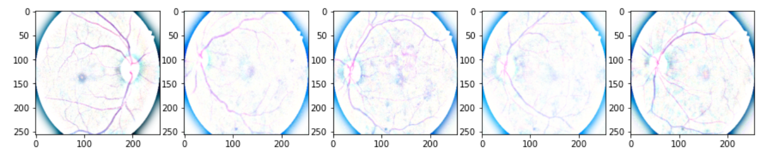

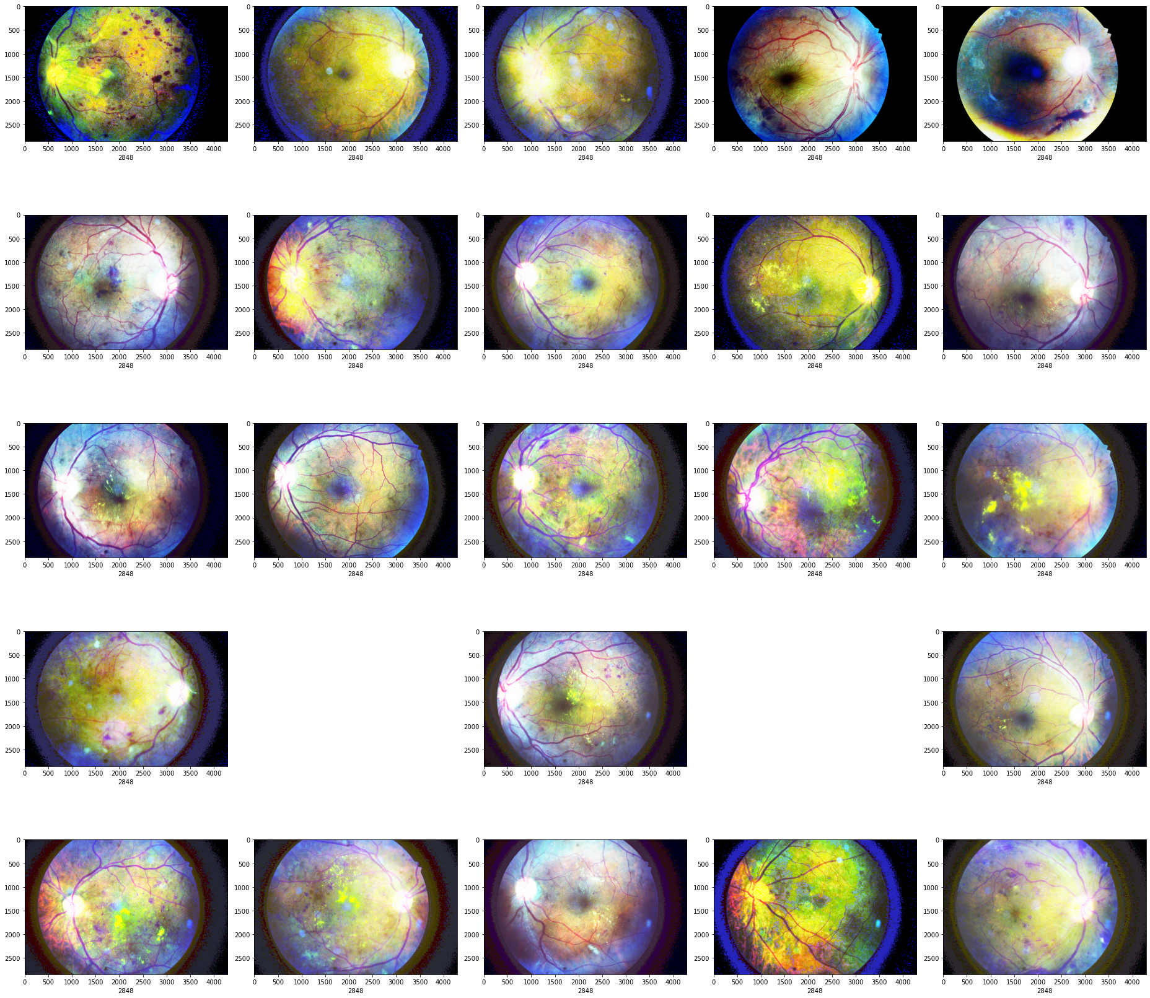

Ok preprocessing methods seem to works fine; however, the doctors to estimate the severity levels in the past competitions may have different criteria in mind than the doctors of Aravind, so it is possible to have some estimation inconsistency.

Some pictures seem to lost details

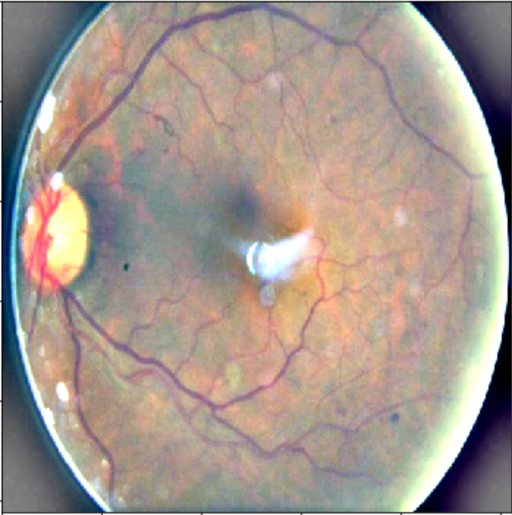

**Evaluate the results:**

Here we evaluate the results by loading the best version of the model and seeing how the predictions look on the results.

|  | SVM | KNN | Logistic  Regression | ANN | ANN  Without batch | CNN |
| --- | --- | --- | --- | --- | --- | --- |
| Train Accuracy | 46.55 | 53.88 | 53.8 |  |  |  |
| Test Accuracy | 59.6 | 51.92 | 48.01 | 69.23 | 46.1 | 70.2 |
| F1 Score Class 'NoDR' | 0.71 | 0.67 | 0.78 |  | 0.51 |  |
| F1 Score Class 'Mild' | 0 | 0 | 0.40 |  | 0 |  |
| F1 Score Class Moderate | 0.62 | 0.56 | 0.45 |  | 0 |  |
| F1 Score Class Severe | 0 | 0 | 0.0 |  | 0 |  |
| F1 Score Class  ProliferatieDR | 0 | 0 | 0.12 |  | 0 |  |
|  |  |  |  |  |  |  |
|  |  |  |  |  |  |  |
|  |  |  |  |  |  |  |
|  |  |  |  |  |  |  |

**According to out results CNN has the biggest result value and others respectively KNN, SVM and Logistic Regression.**

**Logistic Regression vs SVM:**

**SVM supports both linear and non-linear solutions using kernel trick.**

**SVM handles outliers better than LR.**

**Both perform well when the training data is less, and there are large number of features.**

**LR vs KNN:**

* **KNN is a non -parametric model, whereas LR is a parametric model.**
* **KNN is slow in real-time as it have to keep track of all training data and find the neighbor nodes, whereas LR can easily extract output from the tuned θ coefficients.**

**LR vs Neural Networks:**

* **Neural networks need large training data compared to LR model, whereas LR can work well even with less training data.**
* **NN will be slow compared to LR.**
* **Average accuracy will be always better with neural networks.**

**KNN vs SVM :**

* **SVM take cares of outliers better than KNN.**
* **If training data is much larger than no. of features(m>>n), KNN is better than SVM. SVM outperforms KNN when there are large features and lesser training data.**

**KNN vs Neural networks:**

* **Neural networks need large training data compared to KNN to achieve sufficient accuracy.**
* **NN needs lot of hyperparameter tuning compared to KNN.**

**ANN Model:**

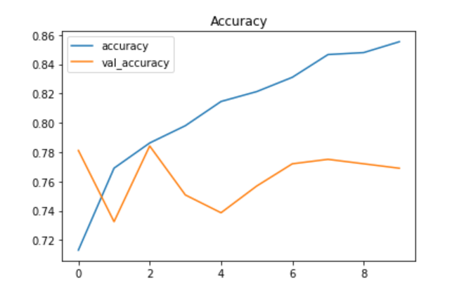

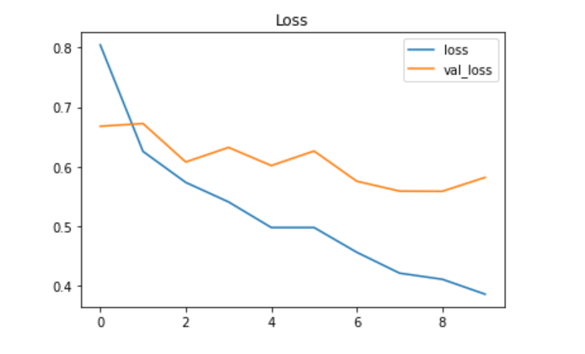

Test Loss: 1.67879

Accuracy on the test set: 0.69%

**Attention Model:**

The basic idea is that a Global Average Pooling is too simplistic since some of the regions are more relevant than others. So we build an attention mechanism to turn pixels in the GAP on an off before the pooling and then rescale (Lambda layer) the results based on the number of pixels. The model could be seen as a sort of 'global weighted average' pooling. There is probably something published about it and it is very similar to the kind of attention models used in NLP. It is largely based on the insight that the winning solution annotated and trained a UNET model to segmenting the hand and transforming it. This seems very tedious if we could just learn attention.